Goal: find word “galleon”

Task: find the search bar

Task: search the result

The main task was to search for a specific word. To do this, the user would have to find the search bar and search for the word. Then click on the search button to find the word that they are looking for.

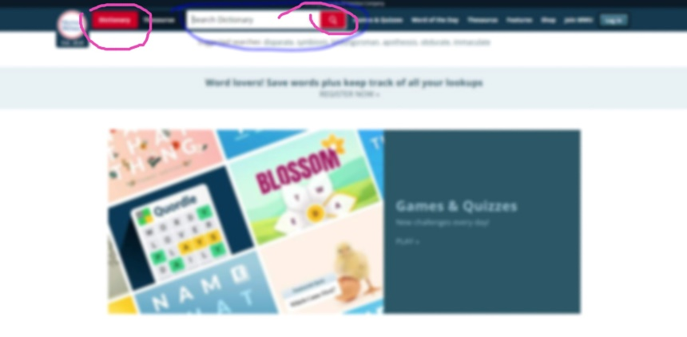

The reason I circaled this one is because most of the macula finds more of red then other colors as such the red buttons stand out. Although there are other colors since they look too much like gray, its easy to loose focuse on the other things.

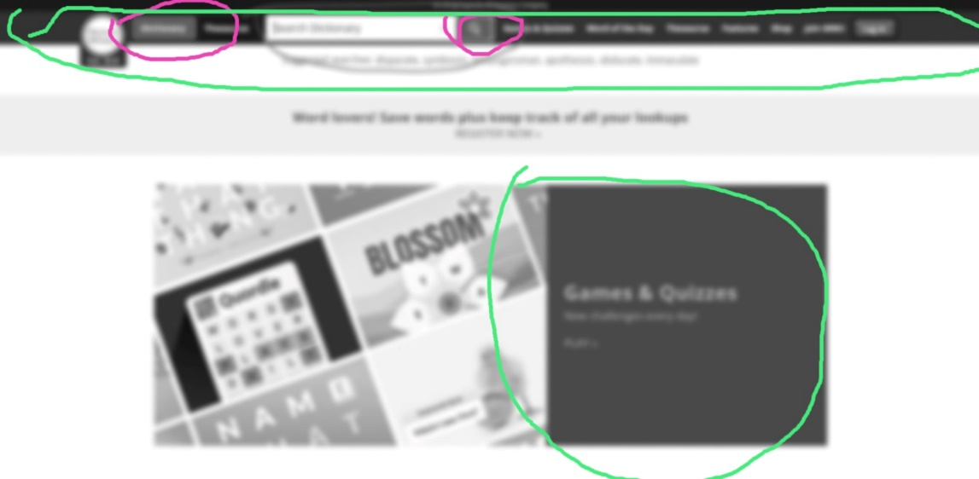

With no color, the navigation bar and the main text on the front page stand out as prefere sees the gray of the screen. Its also interesting to find the white space in the nav bar but because most site is white, its not too knoticeable.

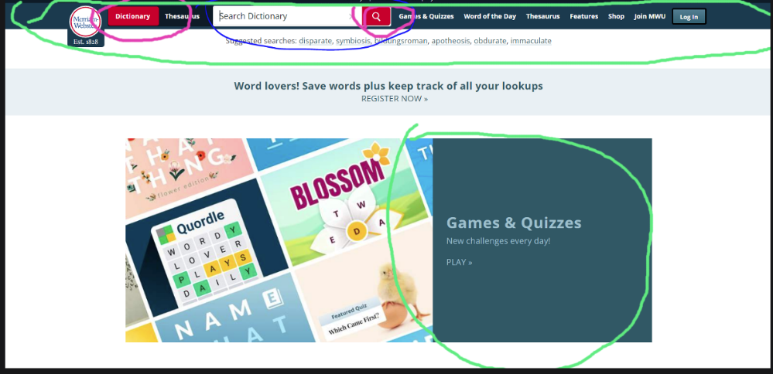

It was one of the more easy to knotice for the task as there are very few red in the page but because we tend to focuse more on the color red then the more prominent color of the website, the search button pops out with possibility to use the dictionary function of the page.

The ease of useage was very straight forward as its very hard to miss the bright red search button and the search bar next to it. The website it self was not too distracting as most of the site is simple and the needs are right on the top of the site. Its important also to remember that this site is most likely used by students or workers who are less wanting to be distracted as such, the site well suits the need of the customers.